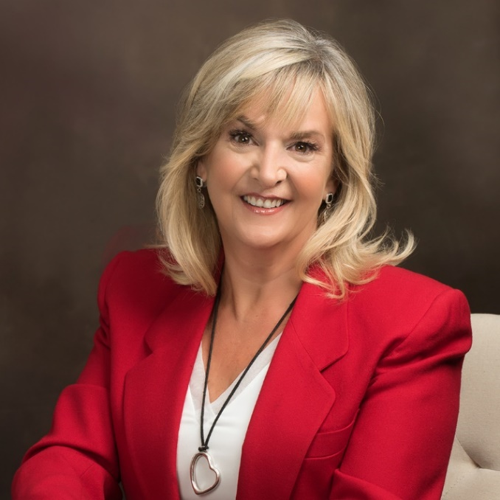
Bio:
Rhonda Petit is a Sales and Business Peak Performance Coach with 35 years of Sales and Sales Management experience in Corporate America in the life sciences and diagnostic markets. She has experience working with Fortune 500 and Fortune 1000 companies. Today she works enthusiastically with Corporations and Individuals with champion mindsets, who know school is never out, who want to continually grow to unleash and activate more of their true potential and power. She helps people discover their deepest desires, leverage the untapped potential in their hearts, activate their potential and achieve their personal and professional goals so they can create the life they want and realize true fulfillment.
Rhonda is a seasoned Sales Professional, a certified coach, leader, in-demand speaker, and author of “The Spirit of Selling.”
Rhonda offers services for personal and professional development as well as sales skill and leadership training. She has been studying personal growth and development for more than 10 years and is thrilled that she has turned her passion into a business that helps people live happy, healthier, more abundant lives. She is excited about changing the culture of Corporate America to one that recognizes their employees as their most precious asset and their professional development their strongest competitive advantage. By working with Rhonda corporations and individuals benefit from an environment at work and home that embodies critical thinking, imagination, cooperation, collaboration, creativity, connection, and fun!
Clients that work with Rhonda are experiencing quantum leaps in their performance, providing greater service to the marketplace, experiencing a sense of true fulfillment and realizing increased profits and improved employee retention.
Rhonda loves Sales and Coaching. Everyone is in sales whether they realize it or not. If you’d like to create the life and culture you’ve been dreaming of, contact Rhonda.
www.3x5coaching.com
Email: info@3x5coaching.com Phone: 267-272-2501

